Minutes of Meeting

Date: Monday 29/01/2018

Time: 15.30

Attendees: Niall Collins and Michael Russell

Where: Athlone Institute of Technology Room U302

1. Project plan

* Using Excel put a weekly plan in place from now till project completion

1. User stories

* Easy backlog and how to approach making user stories from firstly looking at it from customer side

1. Black box/White box testing

* Research both types of testing further

1. Functionality of the project

* Look into the functionality of project and what needs to be done to reach this goal

1. The two differnet versions of the project ie the background research and the frontal development

* When planning the project make sure to know the differnce of what is happening in the project development stage and the background research stages

**To dofor next week…**

1. Look at the Functionality of the project, see if all devices will work within the radius of the barrier or does a certain device have to install app before it will work, this needs to be done before I can start on the project plan. (2 Hours)
2. Construct a Project plan in Excel stating what I want to do week to week starting from this week until the completion of the project, this will be a good way of time management so that I will reach each milestone ontime. (5 Hours) Draft to follow;

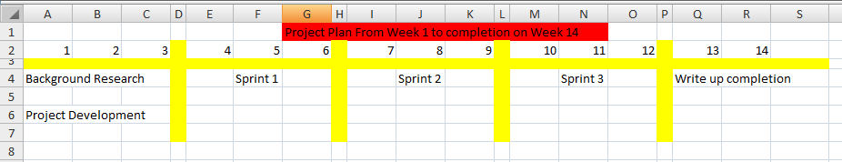

1. Start User stories using Easy Backlog looking at it firstly from customer point of view making a list of requirements that I would like to see upon completion and then turning those into my user stories. (7 Hours)
2. Watch YouTube tutorials on the different techniques accossiated with both Black Box and White Box testing. (1 Hour)